Day 8 — DAG and Spark Execution

cat build.sbt
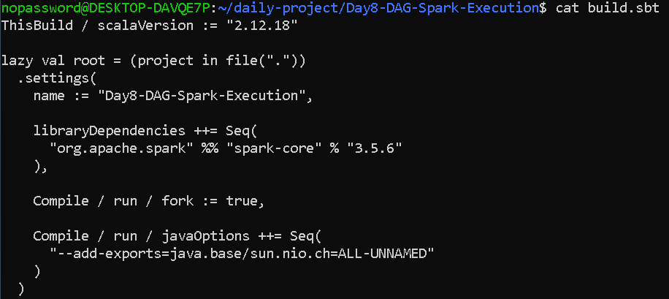

cat data/sales.txt
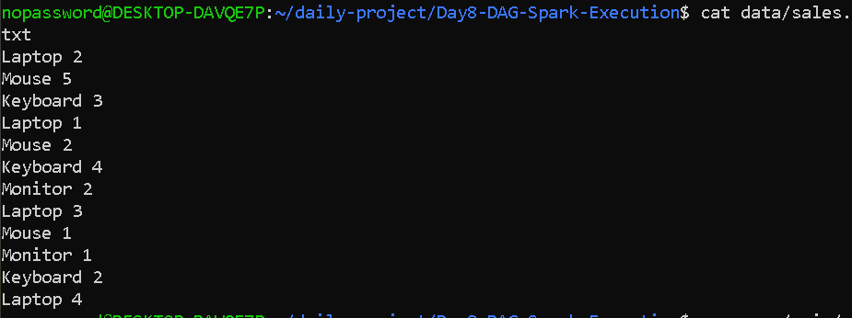

cat > src/main/scala/Day8DAG.scala <<'EOF'

import org.apache.spark.{SparkConf, SparkContext}
> import org.apache.spark.scheduler._
>
> class ExecutionListener extends SparkListener {

overr>
> override def onJobStart(jobStart: SparkListenerJobStart): Unit = {
> println()
> println(">>> JOB STARTED")
> println(s"Job ID: ${jobStart.jobId}")
> println(s"Stage IDs: ${jobStart.stageInfos.map(_.stageId).mkString(", ")}")
> }
>
> override def onStageSubmitted(stageSubmitted: SparkListenerStageSubmitted): Unit = {
> val info = stageSubmitted.stageInfo
> println()
println(> println(">>> STAGE STARTED")
> println(s"Stage ID: ${info.stageId}")
> println(s"Stage Name: ${info.name}")
> println(s"Number of Tasks: ${info.numTasks}")
> }
>
> override def onTaskEnd(taskEnd: SparkListenerTaskEnd): Unit = {
> println(
COM> s">>> TASK COMPLETED | Stage: ${taskEnd.stageId} | " +
> s"Task: ${taskEnd.taskInfo.taskId} | " +
> s"Partition: ${taskEnd.taskInfo.index}"
> )
> }
>
> override def onStageCompleted(stageCompleted: SparkListenerStageCompleted): Unit = {
> println()
> println(">>> STAGE COMPLETED")
> println(s"Stage ID: ${stageCompleted.stageInfo.stageId}")
> }
>
> override def onJobEnd(jobEnd: SparkListenerJobEnd): Unit = {
> println()
rintln(> println(">>> JOB COMPLETED")
> println(s"Job ID: ${jobEnd.jobId}")
> println(s"Result: ${jobEnd.jobResult}")
> }
> }
>
> object Day8DAG {
main(a>
> def main(args: Array[String]): Unit = {
>
val co> val conf = new SparkConf()
> .setAppName("Day8-DAG-Spark-Execution")
> .setMaster("local[4]")
.set(> .set("spark.serializer", "org.apache.spark.serializer.JavaSerializer")
> .set("spark.ui.enabled", "false")
>
> val sc = new SparkContext(conf)
>
> sc.setLogLevel("ERROR")
.addSpa>
> sc.addSparkListener(new ExecutionListener)
>
> println()
> println("==============================================")
> println(" DAY 8 - DAG AND SPARK EXECUTION")
> println("==============================================")
>
> // INPUT
> val lines = sc.textFile("data/sales.txt", 4)
>
> println()
> println("INPUT")
println> println("----------------------------------------------")
> println(s"Input partitions: ${lines.getNumPartitions}")
>
> // NARROW TRANSFORMATION 1
l parsed> val parsed = lines.map(_.split(" "))
>
> // NARROW TRANSFORMATION 2
> val validRecords =
> parsed.filter(parts => parts.length == 2)
>
NARR> // NARROW TRANSFORMATION 3
> val pairs =
valid> validRecords.map(parts => (parts(0), parts(1).toInt))
>
> // WIDE TRANSFORMATION
> // SHUFFLE HAPPENS HERE
> val totals =
> pairs.reduceByKey(_ + _)
>
> // NARROW TRANSFORMATION AFTER SHUFFLE
> val finalResult =
> totals.map {
> case (product, quantity) =>
> s"$product -> $quantity"
}

> }
>
> println()
print> println("TRANSFORMATION PIPELINE")
> println("----------------------------------------------")
> println("1. textFile()")
> println("2. map() -> NARROW")
> println("3. filter() -> NARROW")
> println("4. map() -> NARROW")
> println("5. reduceByKey()-> WIDE / SHUFFLE")
println> println("6. map() -> NARROW")
> println("7. collect() -> ACTION")
>
> println()
> println("SHUFFLE BOUNDARY")
> println("----------------------------------------------")
print> println("reduceByKey() creates a shuffle.")
print> println("Therefore the main pipeline has 2 stages:")
> println("Stage 0 -> transformations BEFORE shuffle")
> println("Stage 1 -> transformations AFTER shuffle")
>
> println()
ln("R> println("RDD LINEAGE")
> println("----------------------------------------------")
> println(finalResult.toDebugString)
>
> // ACTION 1
> println()
> println("==============================================")
> println(" ACTION 1: COLLECT")
> println("==============================================")
>
l result> val result = finalResult.collect()
>
println> println()
> println("FINAL RESULT")
> println("----------------------------------------------")
>
> result.sorted.foreach(println)

// >
> // ACTION 2
> println()
> println("==============================================")
> println(" ACTION 2: COUNT")
> println("==============================================")
>
> val count = finalResult.count()
>
> println(s"Number of final records: $count")
>
> // PARTITIONS
> println()
println> println("==============================================")
> println(" PARTITION INFORMATION")
> println("==============================================")
>
> println(s"Input partitions : ${lines.getNumPartitions}")
> println(s"Pairs partitions : ${pairs.getNumPartitions}")
> println(s"Final partitions : ${finalResult.getNumPartitions}")
>
> println()
> println("==============================================")
> println(" DAY 8 SUMMARY")
> println("==============================================")
>
intln("> println("Jobs are created by actions.")
rintln(> println("Stages are separated by shuffle boundaries.")
rintln(> println("Tasks execute work on partitions.")
> println("map() and filter() are narrow transformations.")
print> println("reduceByKey() is a wide transformation.")
> println("reduceByKey() creates a shuffle.")
> println("Main reduceByKey pipeline = 2 stages.")
>
> println()
> println("==============================================")
> println(" APPLICATION COMPLETE")
> println("==============================================")
>
> sc.stop()
}
}
> }
> }
>EOF

OUTPUT—
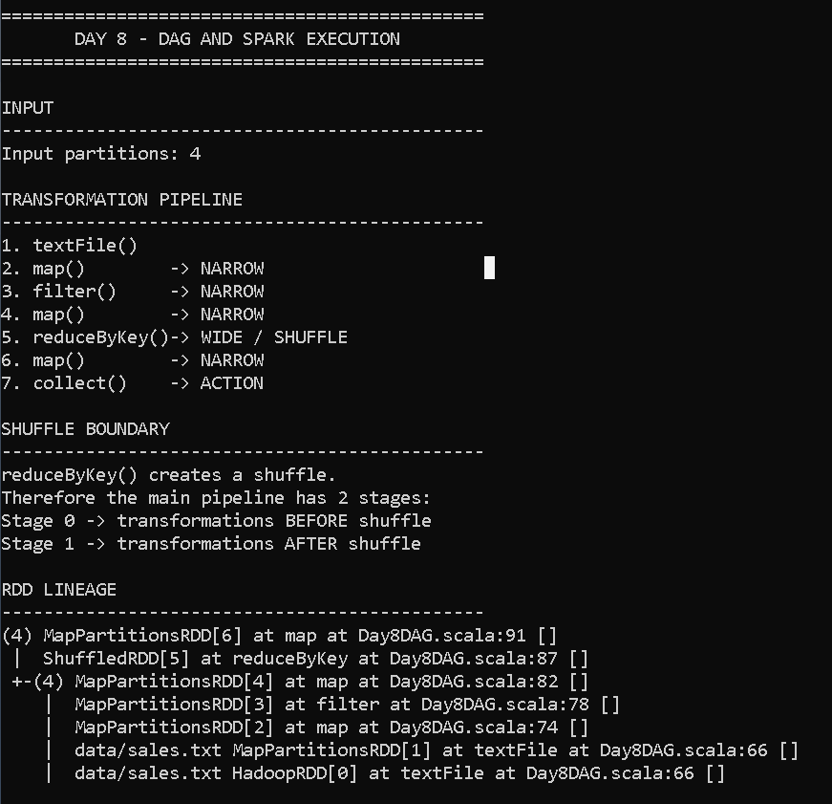

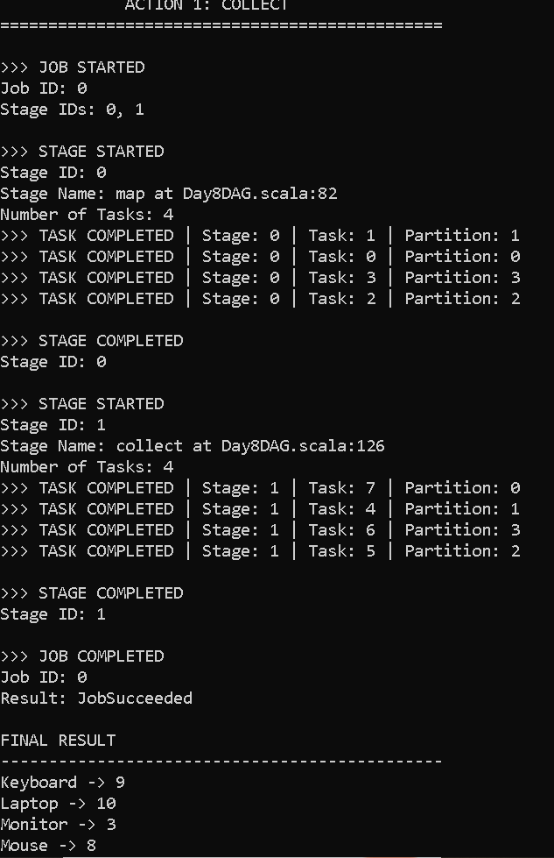
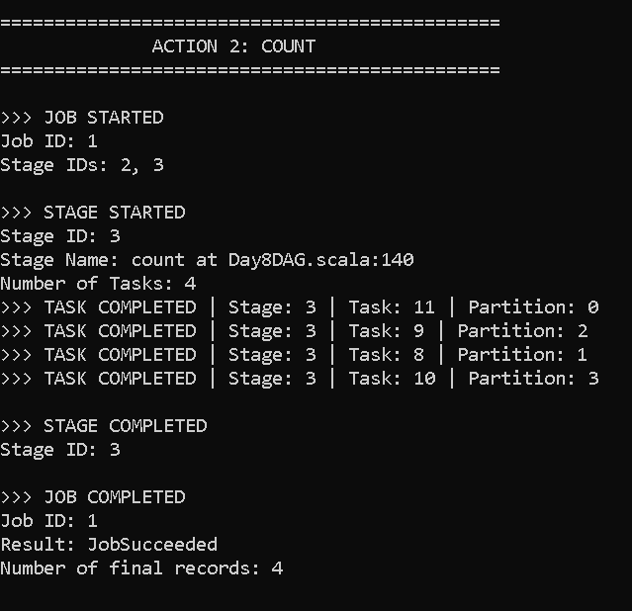

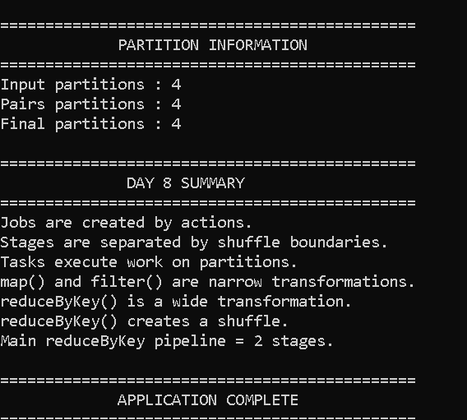

Day 8 — DAG and Spark Execution

1. Objective
The objective of this assignment is to understand how Apache Spark executes an application internally using a Directed Acyclic Graph (DAG).
The assignment demonstrates:
- Creating a Spark job containing multiple transformations and actions.
- Understanding Spark DAG construction.
- Identifying jobs, stages, tasks and partitions.
- Identifying shuffle boundaries.
- Understanding narrow and wide transformations.
- Predicting the number of stages in a reduceByKey pipeline.
- Observing Spark execution using the Spark Web UI.

2. Technologies Used
- Apache Spark 3.5.6
- Scala 2.12.18
- SBT
- Java 17
- Ubuntu / WSL
- Spark Web UI

3. Project Structure
Day8-DAG-Spark-Execution/
│
├── build.sbt
│
├── data/
│ └── sales.txt
│
└── src/
└── main/
└── scala/
└── Day8DAG.scala

4. Input Dataset
The input file contains simple product sales records.
Example:
Laptop 2
Mouse 5
Keyboard 3
Laptop 1
Mouse 2
Keyboard 4
Monitor 2
Laptop 3
Mouse 1
Monitor 1
Keyboard 2
Laptop 4
Each record contains:
Product Quantity
The objective is to calculate the total quantity sold for each product.

5. Spark DAG
DAG stands for Directed Acyclic Graph.
In Spark, a DAG represents the sequence of transformations that must be performed on the data before an action produces a result.
It is called:
- Directed because the operations have a defined direction.
- Acyclic because the execution graph does not contain cycles.
- Graph because operations and dependencies form connected nodes.
Spark uses the DAG to determine how an application should be executed.
The pipeline used in this assignment is:
Text File
|
v
map()
|
v
filter()
|
v
map()
|
v
reduceByKey()
|
| Shuffle
v
map()
|
v
collect()

6. Transformations
A transformation creates a new RDD from an existing RDD.
Examples used in this project are:

map()
map() transforms each input element into another element.
Example:
val parsed = lines.map(_.split(" "))
The input:
Laptop 2
becomes:
Array("Laptop", "2")
map() is a narrow transformation.

filter()
filter() keeps only records that satisfy a condition.
Example:
val validRecords =
parsed.filter(parts => parts.length == 2)
Only records containing two fields are retained.
filter() is a narrow transformation.

map()
The next map() converts the records into key-value pairs:
val pairs =
validRecords.map(parts => (parts(0), parts(1).toInt))
For example:
Laptop 2
becomes:
(Laptop, 2)
This is also a narrow transformation.

7. reduceByKey()
The important operation in this assignment is:
val totals = pairs.reduceByKey(_ + _)
reduceByKey() combines values belonging to the same key.
For example:
(Laptop, 2)
(Laptop, 1)
(Laptop, 3)
(Laptop, 4)
becomes:
(Laptop, 10)
reduceByKey() is a wide transformation because records with the same key may be located in different partitions.
Therefore, Spark needs to redistribute the records between partitions.
This redistribution is called a shuffle.

8. Shuffle
A shuffle occurs when Spark needs to redistribute data between partitions.
For example, suppose:
Partition 1:
Laptop -> 2
Mouse -> 5

Partition 2:
Laptop -> 1
Keyboard -> 3
To calculate the total for Laptop, Spark needs to bring the Laptop records together.
Therefore:
Partition 1
|
|\
| \
v \
Shuffle
^
| /
| /
Partition 2
After the shuffle:
Laptop -> 3
Mouse -> 5
Keyboard -> 3
Shuffle is an expensive operation because data may need to be transferred between executors.

9. Narrow Transformation
A narrow transformation is an operation where each output partition depends on a small number of input partitions, typically one.
Examples:
map()
filter()
flatMap()
In this project:
map
|
filter
|
map
are narrow transformations.
They do not require a full redistribution of data.

10. Wide Transformation
A wide transformation is an operation where an output partition depends on multiple input partitions.
Examples include:
reduceByKey()
groupByKey()
join()
repartition()
sortByKey()
In this project:
reduceByKey(_ + _)
is the wide transformation.
It causes a shuffle.

11. Stage
A stage is a group of tasks that can be executed together without crossing a shuffle boundary.
Spark divides a job into stages based on shuffle dependencies.
Our pipeline contains one major shuffle:
map
|
filter
|
map
|
reduceByKey
|
SHUFFLE
|
map
|
action
Therefore the job is divided into two stages:
Stage 0
-------
map
filter
map

|
| Shuffle
v

Stage 1
-------
reduceByKey
map
The action such as collect() triggers execution.

12. Job
A Spark job is created when an action is executed.
Examples of actions include:
collect()
count()
reduce()
saveAsTextFile()
This project uses:
finalResult.collect()
and:
finalResult.count()
Therefore, two actions are used and Spark can create separate jobs for these actions.
A job represents a complete computation triggered by an action.

13. Task
A task is the smallest unit of work sent to an executor.
A task normally operates on one partition.
For example, if a stage has:
4 partitions
Spark can create:
4 tasks
for that stage.
Therefore:
1 partition ≈ 1 task
for the execution of a stage.
Tasks are executed by Spark executors.

14. Partition
A partition is a logical division of an RDD.
Spark processes partitions in parallel.
In this project, the input RDD is created using:
val lines = sc.textFile("data/sales.txt", 4)
The second argument requests four partitions.
Therefore the input data can be processed using multiple tasks.
Partitions are important because the number of partitions affects the amount of parallelism.

15. Relationship Between Job, Stage, Task and Partition
The relationship can be represented as:
Application
|
v
Job
|
v
Stages
|
v
Tasks
|
v
Partitions
More precisely:
Action
|
v
Job
|
+---- Stage 0
| |
| +-- Task 0 -> Partition 0
| +-- Task 1 -> Partition 1
| +-- Task 2 -> Partition 2
| +-- Task 3 -> Partition 3
|
+---- Stage 1
|
+-- Task 0 -> Partition 0
+-- Task 1 -> Partition 1
+-- Task 2 -> Partition 2
+-- Task 3 -> Partition 3

16. Lazy Evaluation
Spark transformations are lazily evaluated.
For example:
val parsed = lines.map(...)
does not immediately execute the map() operation.
Spark records the transformation as part of the DAG.
Actual execution starts when an action is called.
For example:
val result = finalResult.collect()
The action causes Spark to execute the required transformations.
Lazy evaluation allows Spark to optimize the execution plan before running the computation.

17. Actions Used
Two actions are used in this assignment.

collect()
finalResult.collect()
collect() returns all elements of the RDD to the driver.
It should only be used when the resulting dataset is reasonably small because collecting a large dataset can consume significant driver memory.

count()
finalResult.count()
count() returns the number of elements in the RDD.
Both operations are actions and can trigger execution of the DAG.

18. DAG and Stage Analysis
The DAG for the main pipeline is:
Input
|
map()
|
filter()
|
map()
|
reduceByKey()
|
SHUFFLE
|
map()
|
Action
The shuffle creates the stage boundary.
Therefore:
Stage 0:
Input
|
map
|
filter
|
map

SHUFFLE

Stage 1:
reduceByKey
|
map
|
Action

19. Scenario: Predict Number of Stages for reduceByKey
Consider:
val result =
sc.textFile("data.txt")
.flatMap(_.split(" "))
.map(word => (word, 1))
.reduceByKey(_ + _)
.map(x => x)
.collect()
There is one shuffle operation:
reduceByKey()
Therefore the pipeline is divided into:
Stage 0
-------
textFile
flatMap
map

|
| Shuffle
v

Stage 1
-------
reduceByKey
map
collect
Therefore:
Number of shuffle boundaries = 1
Number of stages = 2
This is the key answer for the scenario.

20. Why reduceByKey Causes a Shuffle
Suppose the input is:
Partition 1:
(A, 1)
(B, 1)
(A, 1)

Partition 2:
(B, 1)
(A, 1)
(B, 1)
To calculate:
A -> 3
B -> 3
Spark needs to bring all A values together and all B values together.
Therefore data is redistributed between partitions.
This redistribution creates the shuffle boundary.

21. Spark Web UI Observation
The Spark Web UI can be opened at:
http://localhost:4040
The Jobs tab displays jobs and their associated stages.
The Stages tab provides information about stages and tasks.
The UI also provides DAG visualization and shuffle metrics such as shuffle read and shuffle write.
The Spark documentation states that the Jobs page provides a DAG visualization and stage information, while the Stages page provides task and shuffle metrics.

22. Expected Execution
The application contains:
Input RDD
|
v
map()
|
v
filter()
|
v
map()
|
v
reduceByKey()
|
| SHUFFLE
v
map()
|
v
collect()
Expected stage structure:
Job
|
+------------------+
| |
v v
Stage 0 Stage 1
| |
map reduceByKey
filter map
map action
|
+------ SHUFFLE --+

23. Difference Between Narrow and Wide Transformations
Feature | Narrow Transformation | Wide Transformation
Data movement | No major redistribution | Requires redistribution
Shuffle | No | Yes
Dependency | Limited input partitions | Multiple input partitions
Example | map, filter, flatMap | reduceByKey, groupByKey
Stage boundary | Usually no | Yes
Performance | Usually cheaper | Usually more expensive

24. Job vs Stage vs Task vs Partition
Term | Meaning
Job | Complete computation triggered by an action
Stage | Group of tasks separated by shuffle boundaries
Task | Unit of work executed on one partition
Partition | Logical division of an RDD
Shuffle | Redistribution of data between partitions
DAG | Graph representing Spark computation

25. Conclusion
This assignment demonstrated how Spark converts a sequence of transformations into a DAG and then divides the DAG into stages based on shuffle boundaries.
The important observations are:
- Transformations are lazily evaluated.
- An action triggers a Spark job.
- A job is divided into stages.
- A stage contains tasks.
- Tasks process partitions.
- Narrow transformations do not require a shuffle.
- Wide transformations require data redistribution.
- reduceByKey() is a wide transformation.
- reduceByKey() creates a shuffle boundary.
- A pipeline containing one shuffle boundary generally contains two stages for that execution path.
The Spark Web UI can be used to verify the jobs, stages, tasks, DAG and shuffle information generated by the application.

